🌐AI-Driven Development - 30-Day
Challenge-Task-7
Name: Qudsia Ali
Roll no: 382751
Slot: (Friday 6–9 PM)
💡SPECKIT Plus:
Spec-Kit Plus is a modern software development methodology designed for the AI era. It focuses on building software through clear specifications, careful planning, and continuous learning. Instead of only producing code, Spec-Kit Plus also captures the developer’s reasoning, decisions, and useful prompts, which become reusable knowledge for future work. This approach makes development more organized, reduces mistakes, and helps teams or AI tools understand the project better. In simple terms, Spec-Kit Plus ensures that every feature creates both working code and long-term intelligence, making software development faster, smarter, and more reliable.
Spec-Kit Plus also helps you build reusable intelligence and sub agents, so repeated tasks become automated over time.
The process is simple:

Constitution
⬇
Specification
⬇
Plan
⬇
Tasks
⬇
implement.

- Constitution.
The Constitution in Spec-Kit Plus is the foundation-document for a project: a set of global rules and standards defined once at the start and then applied to every feature in that project.
It defines unchangeable (or highly stable) guidelines — such as required code style (type hints, naming conventions), testing requirements (unit tests, testing coverage), error-handling, documentation standards, security and data handling practices, and other architectural principles.

- Specification.
In Spec-Kit Plus, the Specification Phase is when you take an idea for a feature and turn it into a clear, concrete description of what that feature should do. Using the /sp.specify command, you define the requirements, behavior, user stories, acceptance criteria, and edge cases focusing on what you want, why you want it, and for whom, without yet deciding on technology or implementation details. This “specification document” becomes the authoritative reference for that feature, ensuring everyone involved has the same understanding before planning or coding begins.

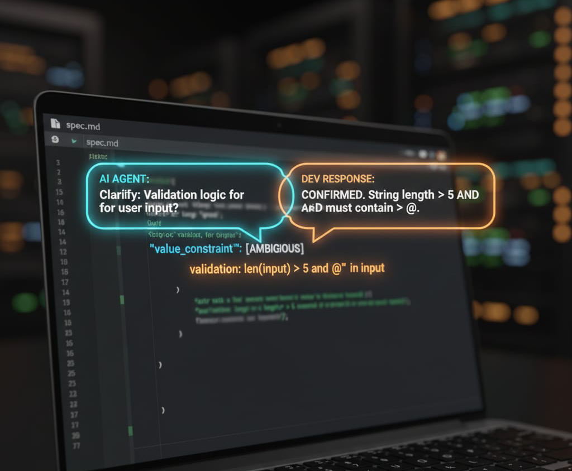
- Plan.
The Plan Phase in Spec-Kit Plus is the step where you take the validated feature specification and turn it into a concrete technical blueprint that tells how you will build the feature. During this phase the system checks your project’s constitution rules (to ensure architectural compliance), then does research if there are unknowns, and finally produces design artifacts — like data models, architecture diagrams or descriptions, and a full “plan.md” document by using /sp.plan command. This plan defines how the feature will be implemented: what components will be needed, how they interact, what data each part uses, and what standards must be followed during coding.



Tasks.
In Spec-Kit Plus, the Tasks Phase is the step where the overall implementation plan is broken down into small, atomic work units — called “tasks.” Each task is designed to be manageable, testable, and reviewable. Each task have a single clear acceptance criterion, and depend on specific other tasks. This granularity ensures that each part of the project can be implemented and reviewed on its own rather than trying to build everything at once like vibe coding. The workflow enforces a checkpoint-driven pattern: after each task the developer reviews the result before committing and moving on preventing big, messy batches of code from being blindly accepted.

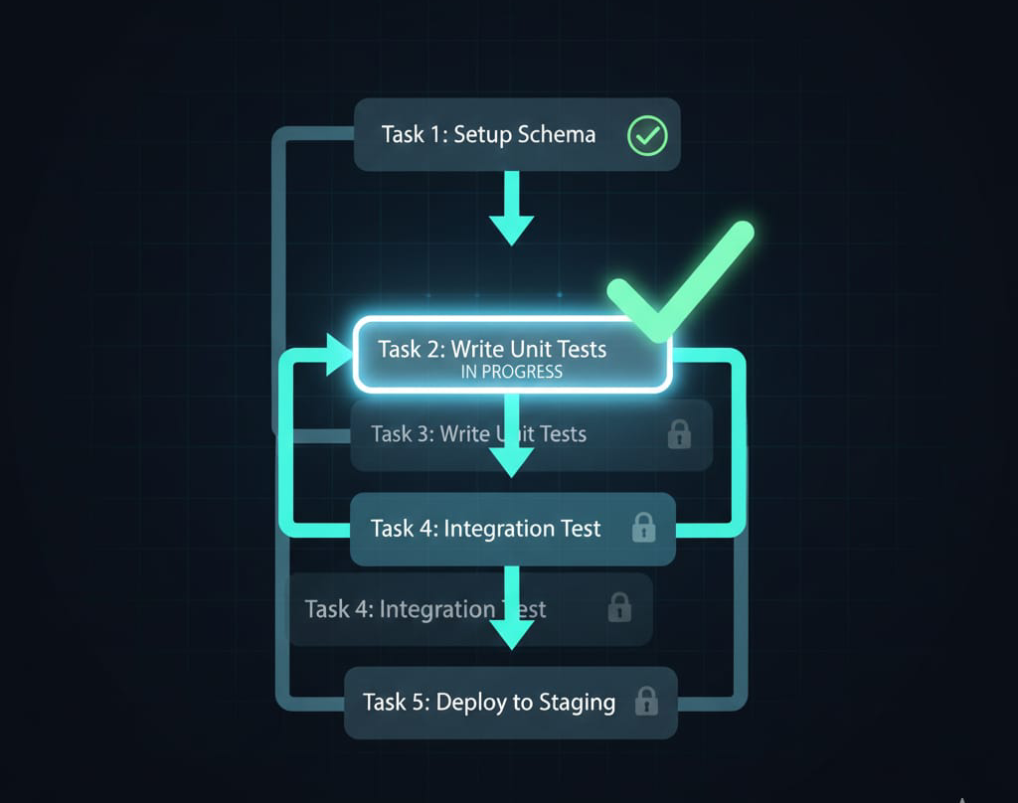
- Implement.
In Spec-Kit Plus, the Implement Phase is where you and an AI-assistant actually build the software: you take the small tasks defined in the previous “Tasks” phase and turn them into working code. In this phase you execute the tasks one by one following the previously defined Constitution the technical plan, and the specification. For each task, code are generated or written, then reviewed carefully , allowing you to check quality, ensure standards, and catch mistakes early. Instead of dumping a large, messy chunk of code all at once.

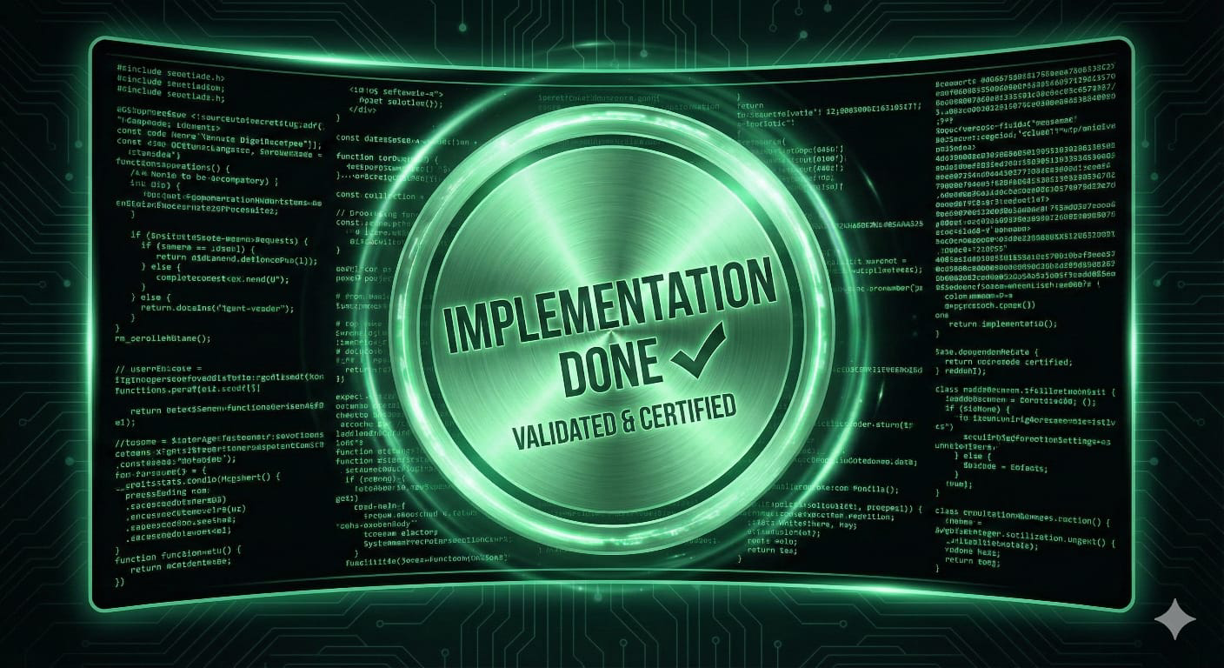

Thank you!
🏷Submitted to Sir Hamza Syed

